Audio MusiKraft
St-Jean, Quebec
Canada J2W 2Y6
audiomusikraft.com
PRESS RELEASE
For immediate distribution

- Audio MusiKraft announces its new Nitro Series Cartridges -

The World’s First and Only «Tunable» and «Customizable» phono cartridge
Saint-Jean-sur-Richelieu, Quebec (November 9, 2019): Audio MusiKraft announces today the audiophile market entry of its improved cartridges. The new Nitro series is up to now our most advanced models. The complete kits are offered in two (2) motor versions (Nitro 1 and Nitro 2) and in four (4) shell (body) alloys to choose from. Each kit includes an improved generator, three (3) pre-selected optimal tonewoods (chosen by us) for you to cover a large musical and sonic spectrum, and it now comes standard with the damping oil treatment, all the necessary voicing, and installation tools in a newly designed wooden jewel box. The Nitro series alloy models are as follow:
- Aluminum (Al), clear or champagne anodized
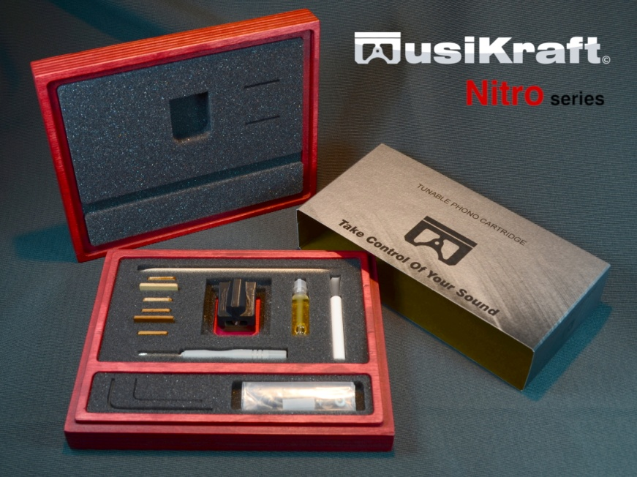
- Lithium (Li), mirror - hand polished
- Magnesium (Mg), chemical conversion coated
- Bronze (Br), gold plated
- Bronze (Br) Collectors, six distinct patina artwork
MSRP from US $2,879 to US $4,139.

Beyond the stylus and the cantilever quality, the magnetic field is one of the fundamental properties of the physical cartridge environment. Our motors have an improved magnetic field and amalgam core composition to attain the best sound. We more precisely control how the array interacts within the generator. Most of our studies are based on stringent trial and error and A/B listening tests. Why the name Nitro? Well for starters it’s related to the improved motors and the shell shape. Secondly, we wanted to add some “Oomph” to better describe what we were seeking and what we were hearing. These are a few resulting key attributes that best reflect the series name: lively, spontaneous, impactful, realistic, tone right, vibrant, musical, and dare we say, downright impressive.

Since the beginning in 2017 we have demonstrated through many excellent reviews that our design is very unique and figures among the best ranking. Always striving to go further, today with the Nitro Series we are offering what we believe is the best of the best at very competitive pricing.
Features and Innovations
- Fully modular design for interchanges between motor, shell, and wood at your will
- Tonality and resonance controllable system
- Three (3) voicing fine-tuning micro setscrews
- Sharp perimeter edges for trouble-free cartridge installation and alignment
- Five (5) different geometric positions for overhang adjustment
- Straightforward to service i.e. quick motor and wood insert installation
- Wide front clearance for stylus ease of view
- Highly durable and recyclable cartridge and shell
- Very precisely machined (± 0.001″)
- Upgradable part options (motor, many wood species, finish and more)
- Almost infinite sonic tuning capability.

About us
Audio MusiKraft is a manufacturer of audio components dedicated to ultra-fidelity. Founded in 2016 by Guy Pelletier, we are a small core of experienced craftsmen and devoted music lovers dedicated to bringing you outstanding components with exceptional value; all the while advancing our utmost goal: True musical fulfillment.
For more information please visit the web store store.audiomusikraft.com

Media kit
For your convenience, we have uploaded various files (including this release) on our Media web page. You can upload the .pdf, .docx or .txt version of this release, various pictures and logos in high resolution and compressed formats at the following link: Media Kit
Disclaimer
Although we strive to make the information in this document helpful and accurate, it is done so without warranties of any kind, either expressed or implied and is subject to change at any time. The Company reserves all of its rights.

For any questions do not hesitate to contact:

Guy Pelletier
Audio MusiKraft
Email to: info@audiomusikraft.com
Website: audiomusikraft.com

- Take Control of Your Sound -

