Contact : Guy Pelletier  Tél.: (514) 266-2441  audiokrafter@gmail.com | Audio MusiKraft  St-Jean-sur-Richelieu, Quebec, Canada J2W 2Y6  audiomusikraft.com/store/en
PRESS RELEASE
For immediate distribution

- Audio MusiKraft announces its official launch -
MusiKraft, the world’s first and only “tweakable” and "customizable" phono cartridge.
Saint-Jean-sur-Richelieu, Quebec (May 9, 2017): Audio MusiKraft announces today the audiophile market entry of its brand new turntable products and online boutique. The MusiKraft shells specifically designed for the Denon DL-103 and DL-103R phono cartridges are all customizable and available in three (3) different metals along with a selection of twenty-four (24) different wood species. Here are some models:
- S-Al in clear or champagne anodized aluminum: from US $229 (bare, without wood insert, nor cartridge)
- S-Al-103 in clear or champagne anodized aluminum: from US $539 (kit form including the DL-103)
- S-AlLi-103 in hand polished aluminum-lithium: from US $739 (kit form including the DL-103)
- S-Mg-103 in chemical conversion coated magnesium: from US $789 (kit form including the DL-103)

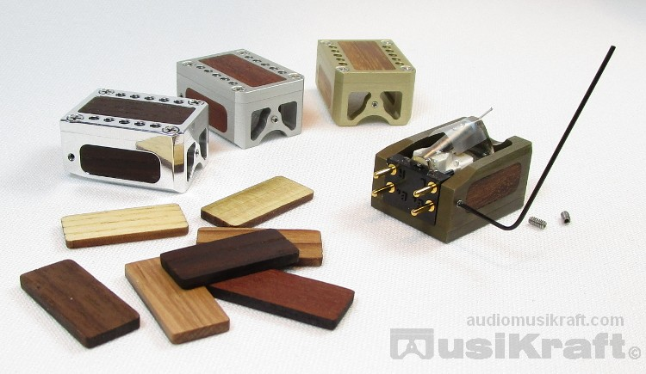
The MusiKraft shell is based on the legendary Denon DL-103 phono cartridge. The product has been designed by longtime vinyl aficionados in search of the ultimate. Four years of research and development were invested and during this period many prototypes were realized and voiced. The present shell morphology is the culmination of all this work and offers many advantages to bring the Denon DL-103 to a much higher level of performance, along with personalizing the sound and looks to the audiophile's taste. To adapt the shell, a modification to the original cartridge is required as the shell system replaces the standard plastic casing. When liberated from its plastic casing and merged to the MusiKraft shell system, the customer is then able to hear and exploit the full potential of the classic Denon cartridge.
- Take Control of Your Sound -

Features and Innovations
- Material combinations on the same housing (metal and wood)
- Precise machining (strict ± 0.001" tolerance)
- Straightforward and quick phono cartridge installation
- Unique lightweight magnesium shell model
- Three (3) metal materials offered
- Interchangeable wood inserts to combine tonality and/or aesthetics (24 available species)
- Various finish and tonal wood treatments
- Three (3) fine tuning micro-screws for voicing
- Five (5) different geometric positions for overhang adjustment
- Simplified front and lateral reference alignment
- Reusable and interchangeable shell

About us
Audio MusiKraft is a manufacturer of audio components dedicated to high fidelity. Founded in 2016 by Guy Pelletier, MusiKraft is a small core of experienced craftsmen and devoted music lovers dedicated to bringing audiophiles outstanding components with exceptional value; all the while advancing our utmost objective: true musical fulfillment. For more information please visit the web boutique audiomusikraft.com/store/en

Disclaimer
Although we strive to make the information in this document helpful and accurate, it is done so without warranties of any kind, either expressed or implied and is subject to change at any time. The Company reserves all of its right.

Media kit
For your convenience, we have uploaded various files (including this release) on our website. You will find these documents, texts, pictures and logos of the company in regular and compressed formats at the following link: Media Kit

For any questions do not hesitate to contact:

Guy Pelletier
Audio MusiKraft
Tél.: (514) 266-2441
email to: audiokrafter@gmail.com

